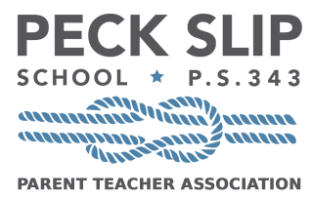
Auction Donation Form
Benefiting Peck Slip School
Spring Gala & Auction, June 6, 2019

DONOR INFORMATION

Donor/business name

Contact name Email

Address

Phone number Fax number

ITEM DESCRIPTION

Description

Retail/estimated value Expiration date

Restrictions (if any)

Donor’s authorized signature

CASH DONATION

If you would like to make a cash donation to our school in addition to, or lieu of an auction item, please enter the dollar amount here: . Checks can be made payable to PECK SLIP SCHOOL PTA.

Corporate sponsorships are also available. If you would like to purchase ad space in our digital journal, please contact Amy Sullivan at Auction@peckslippta.org

Please return this form upon completion, items can be mailed to Peck Slip School PTA Spring Auction, 1 Peck Slip, NEW YORK NY 10038, Donations must be received by Monday, May 13.
All contributions are tax deductible as determined by law. EIN: 61-1694546

Solicited by Phone number

Email Fax

Event Objective: To raise well-needed funds to close the budget gap for quality programming in the area of STEAM education. These funds will support purchases of technology equipment and classroom and art supplies, as well as underwriting teacher training and supplemental arts instruction.

About The Peck Slip School:
Under the leadership of Principal Maggie Siena, The Peck Slip School opened in 2012 in the Department of Education headquarters at 52 Chambers Street. In 2015 the school moved to its beautiful new facility on Peck Slip. Starting with 47 kindergarteners in 2012, each year the school has added a grade, until we reach our full grade span of PreK – 5. Currently there are 376 students in grades Pre-K though 4, with capacity for two prekindergarten classes and five classes on grades K – 5, a total of approximately 960 students. The school offers Integrated Co-Teaching classes in grades K – 4 and classes and has a full-time speech therapist and 2 part-time occupational therapists. Peck Slip students in all grades learn through long-term project-based studies of topics like seeds, birds, the Brooklyn Bridge, and the Lenape, with lessons that integrate reading, writing, history and science, while also learning basic principles of engineering. As one of only two vegetarian non-charter public schools in the nation, the school prides itself on its vegetarian lunchroom.

Thank you so much for your participation in our auction and for your generous support of our school!

